3D Beam Patterns
Kevin Sterne 8/6/2013

Boresight at 14 MHz (1° steps):

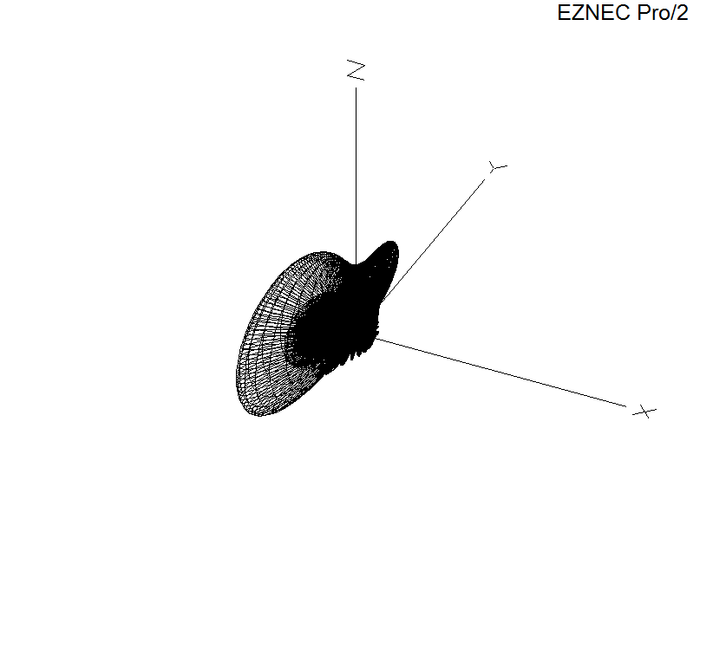

17° off boresight at 14 MHz (5° steps):

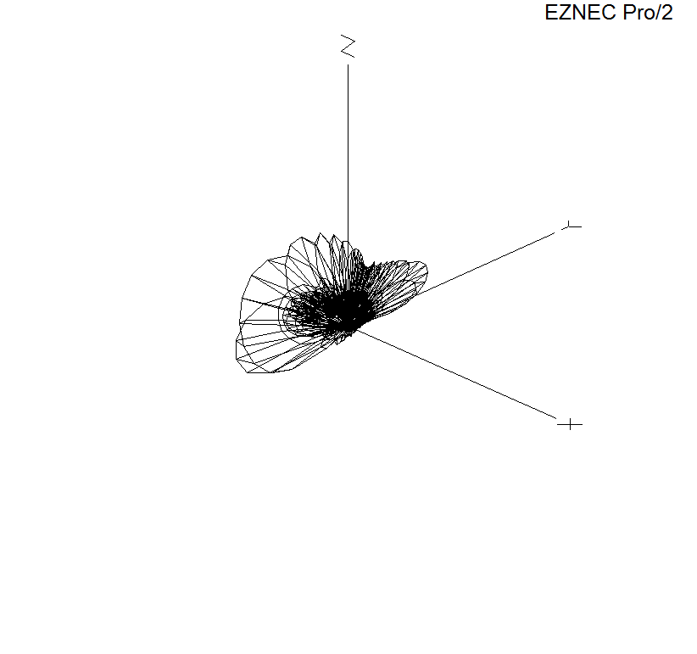
Same phasing, but in 1 deg steps, and azimuth slice at maximum gain (Cursor at 19° off boresight):

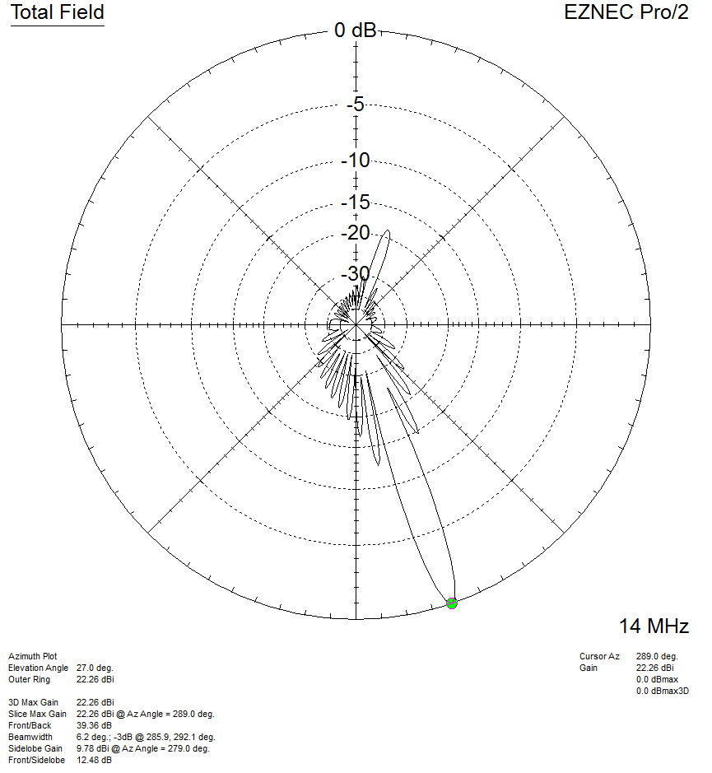

34° off boresight at 14 MHz:

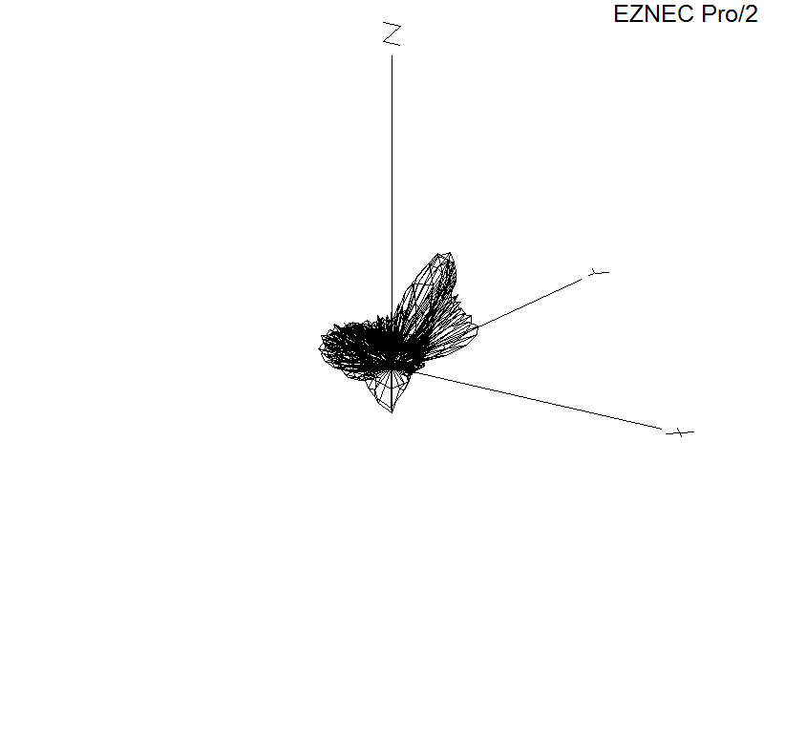

Boresight at 11 MHz:

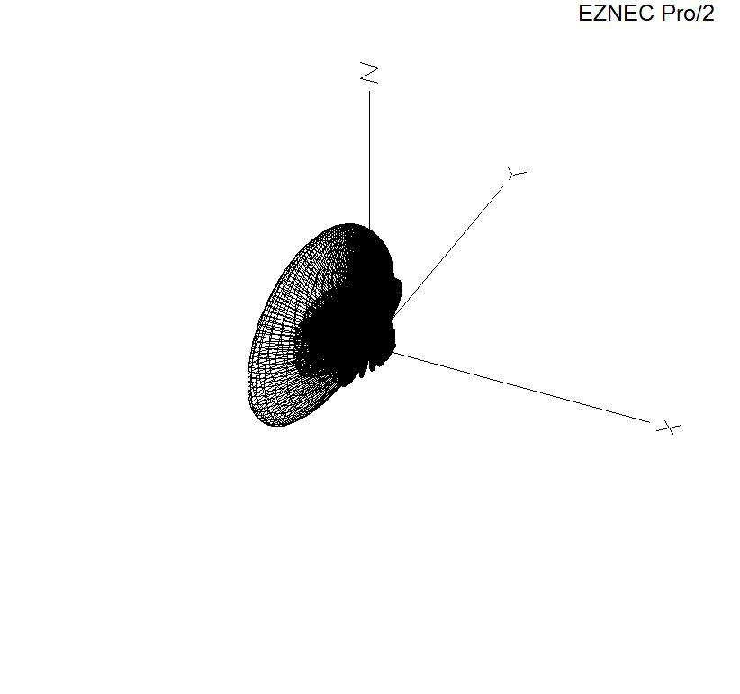
17° off boresight at 11 MHz:

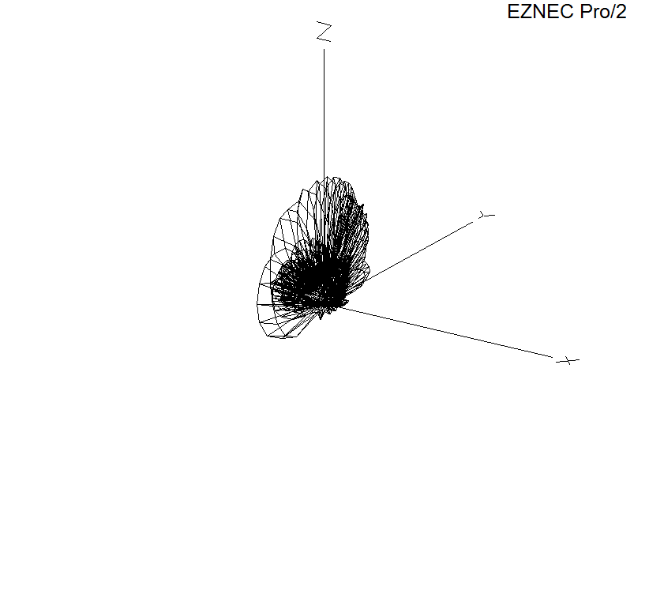
34° off boresight at 11 MHz:

